About the T37 Radio-Controlled Racing Sloop
This 37 inch long wood hull sloop sports a 45 inch mast with 635.5 total square inches of sail area. A 7 inch beam gives her a sleek hard-chined profile; and a shallow keel-fin depth of 11.5 inches allows her to be launched at shoreline. A finished weight of 5 pounds and a removable mast make her easy to transport. A 2-channel radio controls the sails and the rudder.
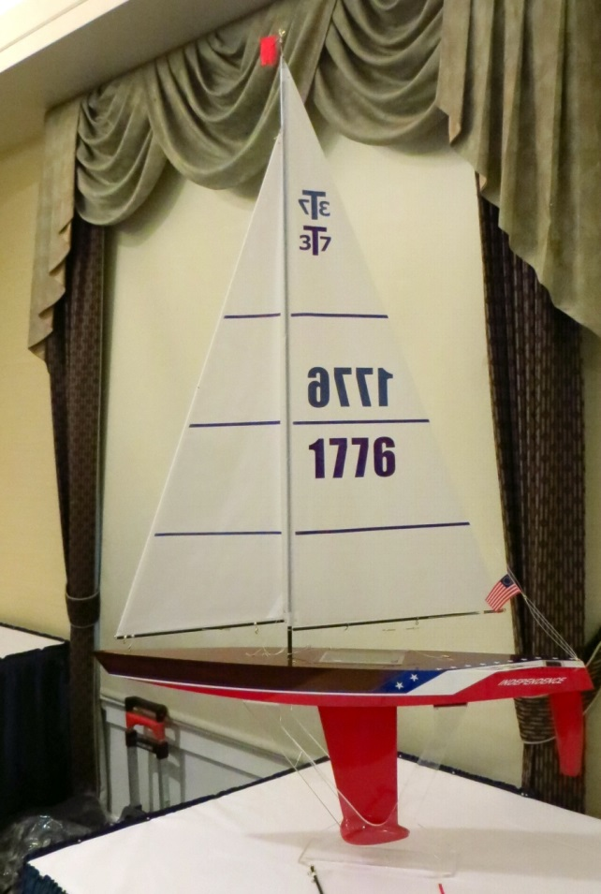
One of the few all wood sailboats to be sanctioned by the AMYA, the T37 is unique for its lack of internal framing or bulkheads. The 1/8 inch mahogany hull sides, bottom and deck are instead joined using a West System epoxy that results in a light, strong composite boat. Available in kit form or as a sail-ready model, the T37 comes complete with electronics, class sails, solid brass or marine grade stainless steel fittings, and lead ballast. Builders need only supply batteries and paint or varnish. The racing upgrade is essential for both the kit and the assembled model and it makes the build simpler. Included in the upgrade are a double throw sheeting system, carbon fiber mast and booms, boom-vang system, and ultra-torque sail servo. (Retrofit kits are available for earlier boats.)
Designed and manufactured by Will Lesh at Tippecanoe Boats in Everson, WA (US), the T37 is a one-design class that allows few variations. The T37 must be assembled using manufacturer’s parts and building instructions to keep things fair. Some discretion is allowed in rigging, rudder configuration, hatch cover, and hull finish. And it is in the finishing that T37 builders may display both craftsmanship and originality. With the silhouette of a classic wooden yacht, the T37 invites a high gloss finish of varnish or paint. Photos of completed models may be found in our T37 Gallery and at the Tippecanoe Boats website.
Roughly 4000 T37 models are now sailed worldwide, with the largest contingent of T37 sailors found in the Pacific Northwest. T37 sailors have the opportunity to join other skippers at more than a dozen venues in Oregon and Washington. Several model sailing clubs in the area host T37 races weekly in addition to special regattas and always welcome new participants and the RC-curious. The T37 Class National Championships are usually held in the Pacific Northwest. See the website of the Pacific Northwest Model Yacht Club [PNMYC.org] for information about venues and model yacht clubs that sail the T37 in the Pacific Northwest.

